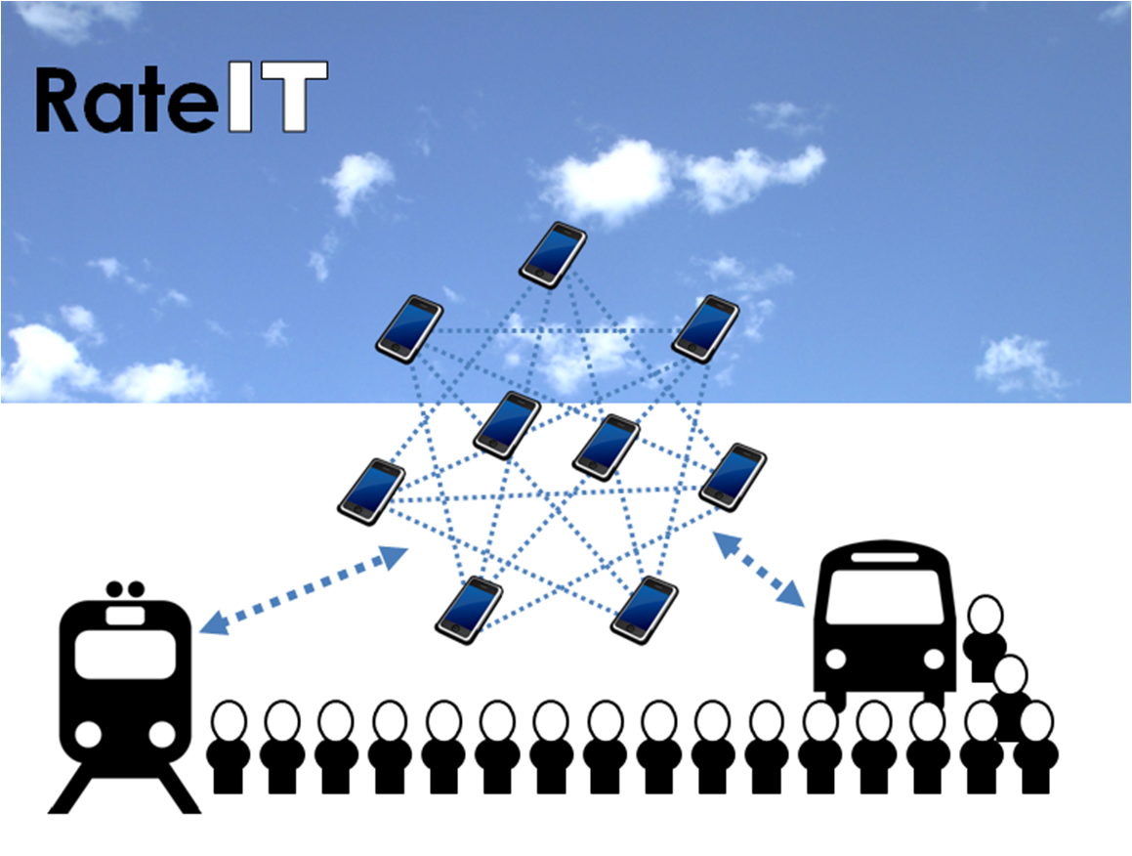

**Functional Scope of the RateIT online app**

This document outlines the Functional Scope of the RateIT online app. It has been prepared to communicate the data needs of the RateIT project to the PTIPS team at Transport for NSW. Please do not circulate without permission of the author.

The document begins with an overview of the RateIT project and how it is organised. The report then focuses on the intended functions of RateIT as it relates to the passenger’s use of public transport. The scope of each function proposed is described in lay terms before outlining the type of information entered into RateIT as input, and the type of information coming out of RateIT as output.

Authors: Dr Claudine Moutou and Dr Thomas Longden

Date: 6 August 2014

Version 2.0

## The RateIT project aims and objectives

The project aims to:

1. Design and develop an online app (compatible with Apple and Android devices) and that can be used to collect and disseminate crowdsourced passenger-to-passenger information in real-time
2. Design and develop the back-end systems that will enable transport operators to capture, interact and respond to real-time information provided by passengers about service quality and passenger experience

The RateIT project will contribute positively to the customer experience as it uses real-time crowd-sourced information to improve performance on service quality indicators. Subjective and objective data collected through RateIT will allow public transport operators to validate customer concerns so as to:

* increase responsiveness of public transport providers to customer concerns
* improve passenger experience and mitigate risks that reduce patronage.
* develop an evidence base to advocate on behalf of customers for land-use improvements
* provide opportunities for value added services e.g. booking additional pick-up service (bus or taxi) if late-running services will result in a number of passengers missing the same connection

This document outlines the Functional Scope of the RateIT app. It includes a description of the function, the type of information entered into RateIT as input, and the type of information coming out of RateIT as output.

## About the organisation of the RateIT project

RateIT’s project team consists of public transport specialists from the Institute of Transport & Logistics Studies and human interaction specialists from the School of IT working with a bus company industry partner, Forest Coach Lines. The strength of the RateIT project team is that it combines research, technology and operational knowledge to create a new space for information exchange about passenger views during their trip which over time will result in a longitudinal dataset to understand how to optimise passenger experience when patronage grows faster than the supply of public transport options.

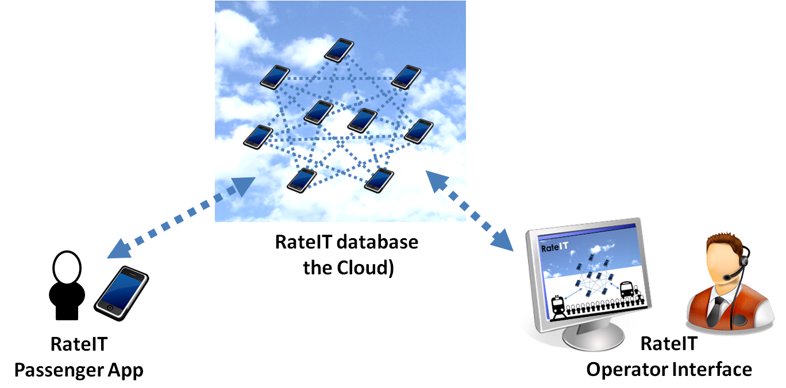

Figure 1: Components of RateIT (input and output)

The components of the RateIT project consist of three main elements (see Figure 1). At the user level the RateIT online app is used by passengers to receive and send data to the RateIT database. The RateIT database stored/accessed through the cloud/internet is the depository of all information which can be queried to provide information to the passenger through the app, or through the Operator Interface. The Rate IT operator interfaces are used by the Bus Operator (Forest Coach Lines) and the RateIT research team (ITLS, School of IT) to access reports or import/export data in the RateIT database. The Operator Interface is also the means that new content or functionality to the RateIT (online) app is updated.

## How RateIT will be used

RateIT is designed to be used by passengers for various stages of their journey. Figure 2 illustrates the different stages as they relate to the journey to work. Passengers may interact with RateIT ahead of getting to the bus stop, at the bus stop, on-board the bus, at the destination stop, or on their way to the destination.

When a passenger is presented with the RateIT app they will see:

* pushed content organised like news alerting them to specific information or request for feedback
* menu items (icons) that allow them to instigate a function, such as checking vehicle type.

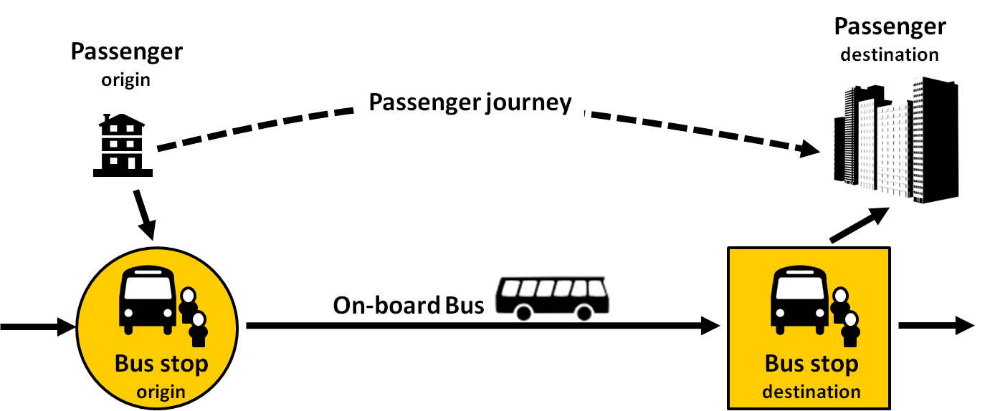

Figure 2: Process map of journey components (journey to work)

## Types of data used by and generated by RateIT

The process map of journey components highlights some of the different types of data that need to be differentiated, and combined to provide meaningful data. Table 1 presents a list of different types of data that RateIT is likely to use. (Note, the list is a work in progress)

Table 1: Differentiating the types of data used within RateIT

|  |  |  |
| --- | --- | --- |
| **Data** | **Description** | **Source** |
| **Bus Stop ID** | Refers to the bus stop infrastructure ID that allows users to specify the location that they wish to board/disembark from a bus | TfNSW |
| **Bus Route ID** | Refers to the route that the bus is following. | TfNSW  Bus operator |
| **Bus Service ID** | Refers to the timetable schedule that the bus is following. *Note: Not clear if this is different to the ID associated with each bus service in PTIPS.* | TfNSW  Bus operator |
| **Vehicle ID** | Refers to the unique identifier of the vehicle that is displayed inside and on the bus. *Note: Not clear if this is different to the GPS ID associated with each bus vehicle and used in PTIPS.* | TfNSW  Bus operator |
| **Driver ID** | Refers to the unique identifier that all authorised bus drivers display in the bus. | TfNSW  Bus operator |
| **Vehicle Info** | Refers to vehicle specifications such as low-floor bus, double-decker / bendy / standard bus, air-conditioned. Vehicle Info linked to **Vehicle ID**. | Bus operator |
| **Bus Service Info** | Refers to data updated daily that identifies which **Vehicle ID** is used for each **Bus Service ID**. | Bus operator |
| **Bus Driver Info** | Refers to data updated daily that identifies which **Driver ID** is used for each **Bus Service ID**. | Bus operator |
| **Bus Occupancy Info** | Real-time data updated to show the estimated current level of occupancy on a bus. Data linked to **Bus Service Info** and real-time information collected through the RateIT app from passengers. | RateIT (real-time) |
| **Passenger ID** | Unique identifier for passengers using RateIT generated at registration. | RateIT database |
| **Passenger Info** | Data record of activity associated with **Passenger ID**. Queries to the RateIT database can pull down passenger preferences and certain statistics of past activity and ratings on service quality indicators. | RateIT database |
| **Service Quality Scores** | Data record of activity associated with different measures of service quality such as: punctuality rate, crowding, cleanliness linked to **Bus Service ID**. | RateIT database |
| **Bus Service Score** | Date specific **Service Quality Scores** associated with a **Bus Service ID**. | RateIT database |
| **Bus Stop Scores** | Data record of different measures of service quality such as: punctuality rate, crowding, cleanliness linked to **Bus Service ID**. | RateIT database |

## Description of proposed RateIT functions

Some example functions that RateIT could offer passengers are listed in Table 2. A survey of Forest Coach bus passengers is scheduled to take place which will help to identify which functions are of greatest importance and more greatly valued by passengers.

Table 2: List of RateIT functions (not in order of priority)

|  |  |  |  |  |
| --- | --- | --- | --- | --- |
| **Function** | | **Description** | **Input required** | **Output provided** |
| **1** | **Check vehicle type** | Passengers select their bus service (route and time) and can see characteristics of the bus (for e.g. low-floor bus, double-decker / bendy / standard bus, air-conditioned, etc). | * PTIPS information showing timetable information * Dataset of Bus Operator vehicles and their specifications * Daily update from Bus Operator about allocation of vehicle on services | * Presentation of information to passenger that is easy to read and sort |
| **2** | **Vehicle preferences** | Passengers can store the characteristics of the bus (for e.g. low-floor bus, double-decker/bendy/standard bus, air-conditioned, etc) that they prefer | * Dataset of Bus Operator vehicles and their specifications * Short form that passengers complete to indicate their preferences | * Information about the passenger preference stored against the passenger user account * Updates to the passenger vehicle preferences stored as a separate time stamped log * Highlighting of services that meet the passenger’s vehicle preferences * RateIT database updated with information about the vehicle preferences of passengers |
| **3** | **Waiting for bus** | Passengers can identify the bus stop or bus service that they are waiting for.  *Supplementary features could include passengers guessing how long they will have to wait, and then comparing this to when the bus arrives. Data stored in RateIT database* | * Bus Stop ID * Bus Service ID * Button to indicate passenger is waiting * *Timer dial for passenger to indicate their guess of waiting time* * *Passenger’s statistics for past guesses of waiting time* | * Count of passengers waiting at Bus Stop ID and for Bus Service ID * Counts stored in RateIT database * Automated feedback counting down the bus arrival * Real-time updates about the Bus Service ID * *Passenger gets a score for the accuracy of their waiting time, which is stored against their profile.* |

|  |  |  |  |  |
| --- | --- | --- | --- | --- |
| **Function** | | **Description** | **Input required** | **Output provided** |
| **4** | **On-board bus** | Passengers log their presence on a bus service | * Bus Service ID * Button to indicate passenger is aboard | * Count of passengers on board added to real-time Bus Occupancy Info * Bus Occupancy Info stored in RateIT database and available |
| **5** | **On-board experience** | Passengers can provide feedback about the on-board bus experience. | * Bus Service ID * Simple survey questions for passengers to provide comment on:   + how full the bus is (scale from empty to full)   + seated or standing   + bus cleanliness   + safety | * Survey responses stored in RateIT database against Passenger ID * Responses added to Service Quality Scores for Bus Service ID |
| **6** | **Rate trip** | Similar to on-board experience but allows passengers to rate qualitative measures of their journey. | * Bus Service ID * Simple survey questions for passengers, for example:   + did you arrive on-time to your destination   + how did the bus trip contribute to your journey (calming / stressful, positively / negatively) | * Survey responses stored in RateIT database against Passenger ID * Responses added to Service Quality Scores for Bus Service ID |
| **7** | **Rate driver** | Passengers can provide feedback about the performance of the bus driver. | * Bus Service ID * Simple survey questions for passengers to provide comment on:   + Driving quality (rough or smooth)   + Communication skills (scale: poor to excellent) | * Survey responses stored in RateIT database against Passenger ID * Responses added to Service Quality Scores |

|  |  |  |  |  |
| --- | --- | --- | --- | --- |
| **Function** | | **Description** | **Input required** | **Output provided** |
| **8** | **Check service quality score** | Passengers can see how a bus service or route has performed in the past.  Distinguish made between current score of a service and historical performance. f a specified bus service or bus route. Queries to the RateIT database can pull down Amalgamated service quality indicators organised by time to differentiate between historical performance, performance by time-of-day and current performance. | * Bus Route ID * Bus Service ID * Bus Service Score * List of available Service Quality Scores (e.g. punctuality rate, crowding, cleanliness) * Query parameters (current, weekday, monthly, etc) | * Service Quality Scores stored in RateIT database |
| **9** | **Rate infrastructure** | Passengers can score the quality of the bus stop infrastructure, and alert Bus Operator to issues | * Bus Stop ID * Simple survey questions for passengers to provide comment on:   + available seating   + appropriate signage   + opinion on shelter   + cleanliness / upkeep of bus stop infrastructure   + issues with lighting, tripping hazards, feelings of safety | * Survey responses stored in RateIT database against Passenger ID * Responses added to Service Quality Scores for Bus Stop ID that can be used to engage the relevant local government authority |
| **10** | **Alert incident** | Passengers can initiate an alert to inform other passengers and operator of an issue. (e.g. traffic incident, sick passenger, anti-social behaviour amongst passengers, lost item) | * Bus Service ID * Bus Stop ID * Simple form to indicate incident type * Simple form to indicate assessment (e.g. traffic incident location, severity) | * Notification of incident report sent to Bus Operator * Data validation rules applied in RateIT database (e.g. referencing Passenger ID to check they have not been flagged as providing false incident alerts) before posted on RateIT for other passengers to see and validate. |

## Types of data required within the database and the operational interface

Some example functions that RateIT database needs to offer operators and the RateIT research team are listed in Table 3. These data are separated into ‘User and session information’ to indicate standard data that could be used to identify different records and track the same user use of RateIT over time. The second category of ‘Trip and location information’ focuses on identifying different journeys taken by users which can help in analysing their trip behaviour, incidents on the same route, and location specific information.

Table 3: Important data for the operator interface and database

|  |  |  |  |  |
| --- | --- | --- | --- | --- |
|  | **Important data for the operator interface and database** | **Information Source** | **Link to Table 1** | **Filter** |
| User and session information | Passenger ID | RateIT database | Yes |  |
| User name | User |  |  |
| Time and date logged in | Registered by app |  |  |
| Time and date logged out | Registered by app |  |  |
| Time and date page submitted | Registered by app |  |  |
| Trip and location information | Bus route | User |  |  |
| Bus route ID | TfNSW | Yes |  |
| Bus stop where journey commenced | User |  | Dependent upon Bus route |
| Bus stop ID | TfNSW | Yes |  |
| Time when boarded the bus | User |  |  |
| Location of incident | User |  | Dependent upon Bus route |
| On-board bus or other part of journey (e.g. at bus stop) | User |  |  |
| Submitting after the incident | User |  |  |
| Geographical location of use of RateIT | User |  | Dependent upon Bus route and on/off bus |

## Process map of trip and location information

Collecting the users’ trip and location information will be an important attribute of RateIT because some of the incidents that they report on may happen during the journey. For e.g. reporting that the bus has got full during the journey requires information about what part of the bus route this has occurred.

Figure 3 provides an example of dynamic questions, organised as a hierarchy that can be utilised to accurately identify a user’s location during their trip.

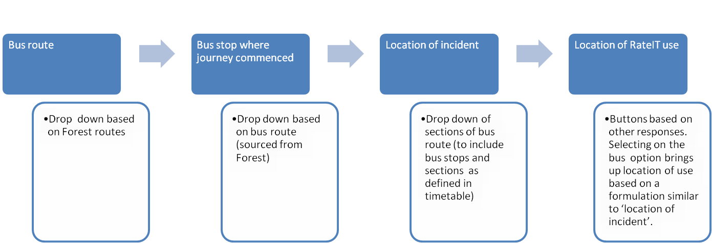

Figure 3: Process map of trip and location information

## RateIT project contact

For more information about the RateIT project please contact:

Dr Claudine Moutou

Institute of Transport and Logistics Studies

The University of Sydney Business School

The University of Sydney NSW 2006

[claudine.moutou@sydney.edu.au](mailto:claudine.moutou@sydney.edu.au)

Tel: 02 9114 1878